Student’s Name: Kibet Brian
Admission Number: 190814
Lecturer’s Name: Mr. Talo Harrison
Course Unit: MST 8303 Penetration Testing, PT
Course Code: MST 8303
SQL Injection DVWA
Date: June 29th, 2025
SQL Injection DVWA
Enabling display_errors and display_startup_errors.
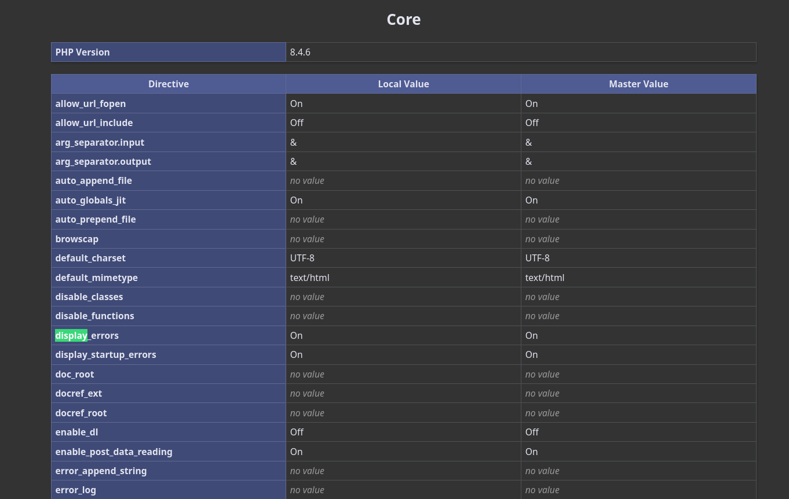

Low
User with ID 1
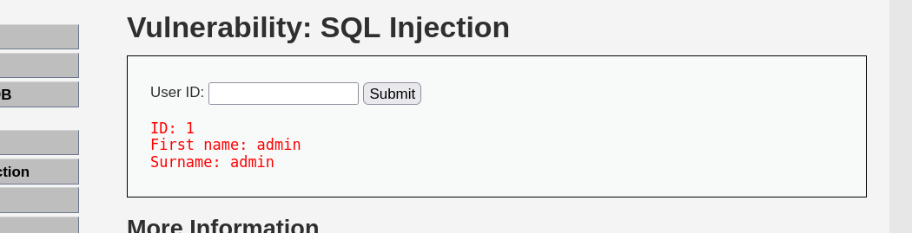

Always true scenario.
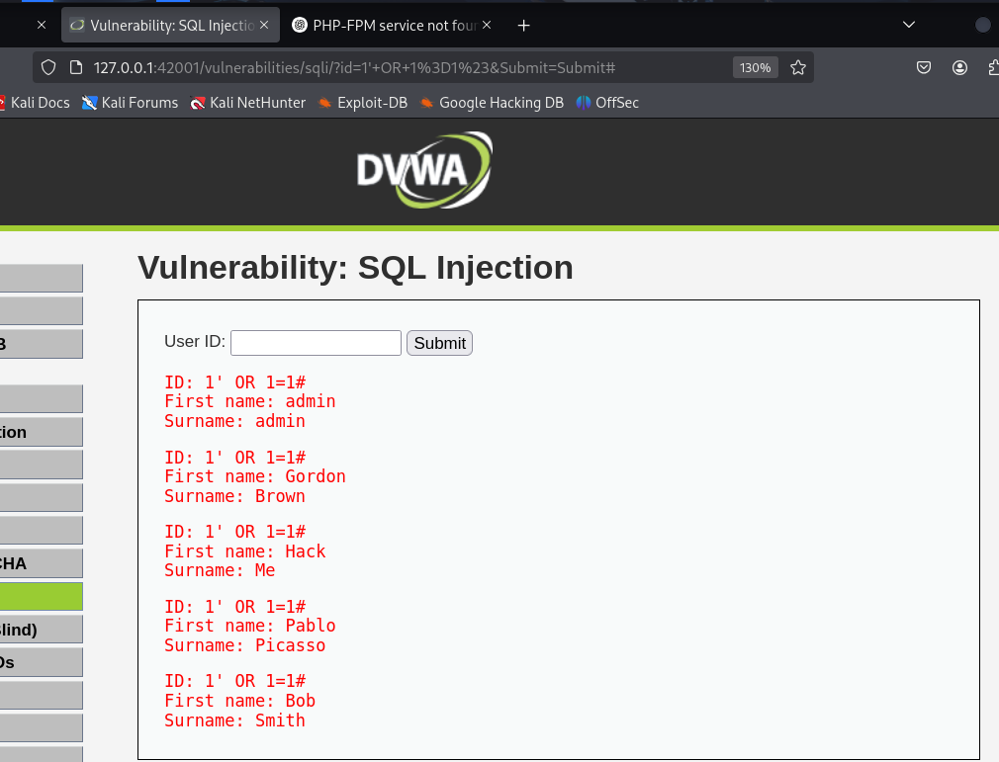

UNION SELECT user, password FROM users#:
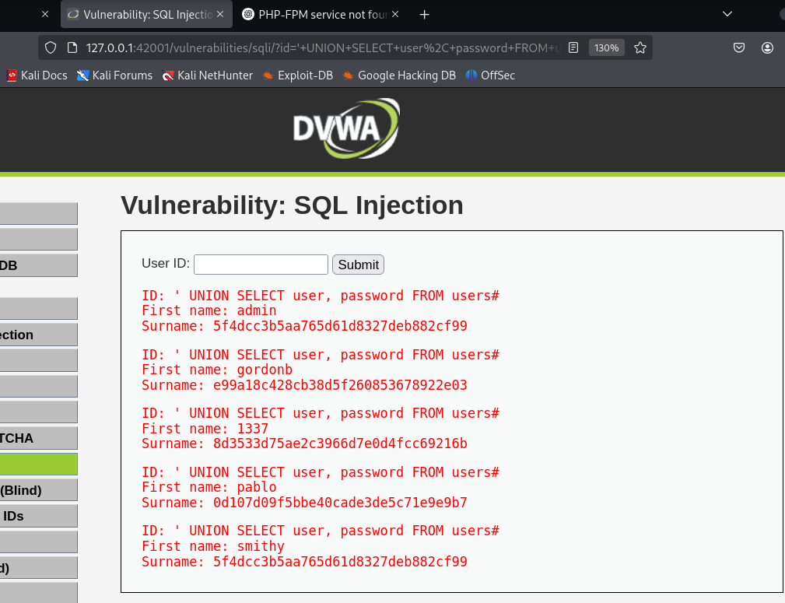
Hash types of hashed passwords.
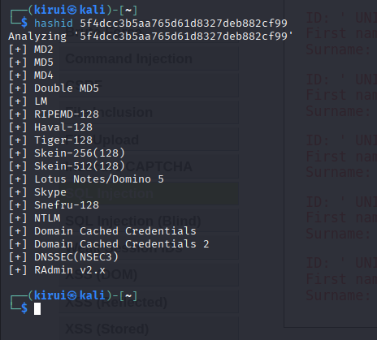
Password cracking
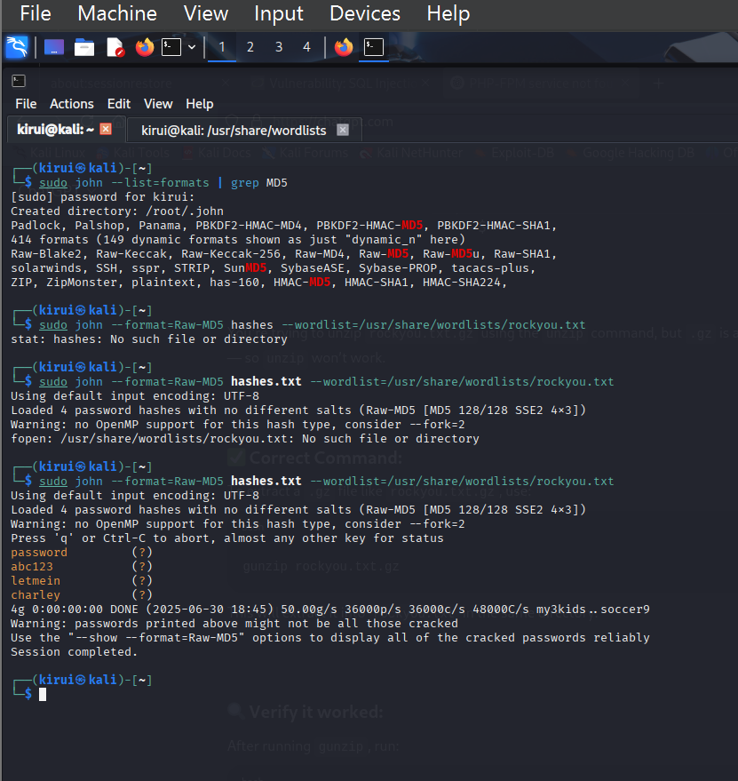
Medium
Using Inspect(Q)
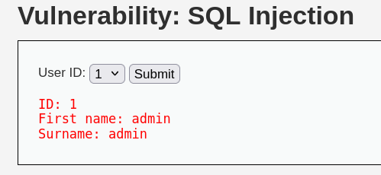
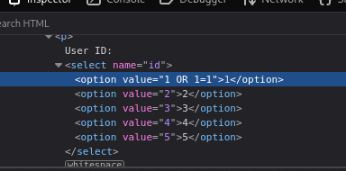

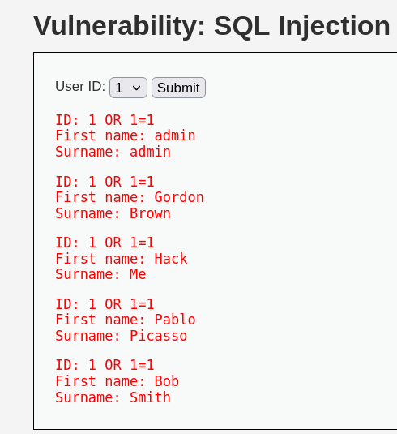
High

UNION SELECT user, password FROM users#:

